Final Game Concept Idea

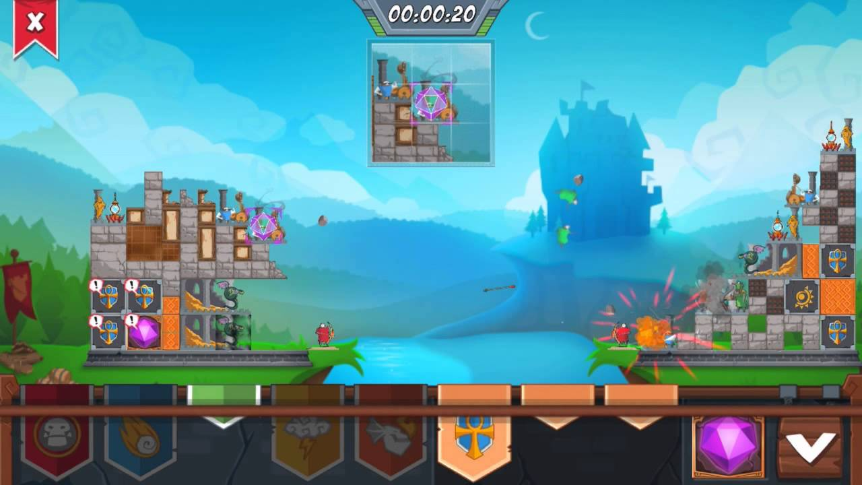After today meeting we have finalised the idea for the game, we have narrowed it down the “attacking another player’s base” game. In the game the players start with identical castles, this way we are keeping the level design symmetrical; because it is a turn-based game, one player will always have an advantage because they will have the starting turn.

The players will shoot projectiles across the map, to destroy the other player’s castle. The camera will pan to the castle of the player that is currently making the move, and in between the turns the camera will pan to show the whole “playground”.

This introduces a trial and error mechanic to our game, where the players will have to guess where the castle is and take few turns before they get the castle. Things like wind and other external forces can affect the projectiles that are shot by the players.